INTERNAL PRODUCT SPECIFICATION (IPS)

MODEL NUMBER ： 6837-101

PRODUCT NAME ： Baxter NPP 3S2P Battery Pack VTC6 Cell

CUSTOMER ： Baxter

REFERENCE : BOM-03-56837-101
BOM-03-56837-101

ICC P/ N : 03-56837-101
03-56837-201

Project Number | Project Name | Cell | ME | Package
03-56837-101 | Baxter NPP 3S2P Battery Pack VTC6 Cell | US18650VTC6
03-56837-201 | Baxter NPP 3S2P Battery Pack VTC6M Cell | US18650VTC6M

THIS SPECIFICATION COVERS THE PERFORMANCE CHARACTERISTICS AND PRODUCTION TEST REQUIREMENT FOR BAXTER NPP battery pack

Revision History
Revision | Originator | Reason for change | Date
X1 | Matthew | New release | Nov/1/2017
X2 | Matthew | Update item 5.1, 5.3.4, 5.3.11, 5.3.12, 5.3.14, 5.3.15, 5.4.1, 7.4 | Nov/10/2017
X3 | Matthew | Update item 5.4.7 | Dec/7/2017
X4 | Matthew | Update item 4.14, 5.3.4, 5.3.7, 5.3.9, 5.3.11, 5.3.12, 5.3.14, 5.3.15 | Dec/15/2017
X5 | Matthew | Update item 4.14, 5.4.7, 5.4.10 | Dec/20/2017
X6 | Matthew | Delete item 5.4.6  Update item 5.4.10 | Feb/07/2018
X7 | Jimmy | Update item 5.3.1 | Mar/5/2018
X8 | Matthew | Update Product information Version List, add Appendix 1 and Appendix 2 | Mar/07/2018
X9 | Jimmy | Update FW item in Product information Version List | Mar/8/2018
X10 | Matthew | Update item 4~5, update Appendix 1 and Appendix 2 | May/16/2018
X11 | Tomato | Add Mechanical part | May/23/2018
X12 | Matthew | Update item 5.3.1  Change the action before PCBA test to “Make sure TP7, TP28 are short to C1-” from “Make sure TP7 are short to C3-” | Jun/8/2018
X13 | Matthew | Item 4.28/Change(Change OVER-DISCHARGE PROTECTION VOLTAGE to 2.50V±25mV/cell from 2.75V±25mV/cell)  Item 5.4.13/Change(Change Over-Discharge voltage to 7.5V±50mv(2.50v/cell) from 8.25V±50mv(2.50v/cell) | Jun/11/2018
X14 | Matthew | Item 5.4.13/Change(Change Over-Discharge voltage to 8.25V±50mv(2.75v/cell) from 7.5V±50mv(2.50v/cell)  Item 5.5.4/5/11a/11b/Update(Update test remark to improve the test efficiency)  Item 5.5.3.e/Change(Change Ia to +/-10mA from 0mA) | Jun/19/2018
X15 | Tina | Update the Production code of Product information Version List | Jun/21/2018
X16 | Matthew | Update item 5.3.1  Item 5.4.9/Change(Change tolerance to 75mV from 50mV)  Item 5.4.10/Change(Change tolerance to 75mV from 100mV)  Item 5.4.13/Change(Change tolerance to 240mV from 100mV) | Jun/28/2018
X17 | Tina | Update item 5 of “Product information Version List” | July/6/2018
X18 | Tina | Update item 2 & 6 of “Product information Version List” | July/18/2018
X19 | Matthew | - Update the remark of item 5.4.7  - Item 5.4.6/Change(Change tolerance to +/-20mV from +/-10mV)  - Item 5.5.3.e/Change(Change tolerance to 0mA from +/-10mA)  - Item 5.5.10/Change the OCV to 9.54~10.89V from 10.35~10.8V  - Update item 4.1.1~4.1.6 | July/25/2018
X20 | Jimmy | Add item 5.5.9 Fuel Gauge Learning | Sep/14/2018
X21 | Matthew | - Item 1 of “Product information Version List”/Update(Update version to Rev3 from draft2)  - Item 8 of “Product information Version List”/Update and Add(Update main board PCB version to B1 from A5, and add flexible board PCB, connector board PCB and NTC flexible board PCB)  - Item 9 of “Product information Version List”/Update(Update version to B3 from A10)  - Item 4.2.8/Change(Change OVER-DISCHARGE PROTECTION VOLTAGE to 2.5V±80mV/cell from 2.75V±80mV/cell)  - Item 5.4.3/Update(Update Action before PCBA function test to “Short TP7 and C1-” from Short TP7, TP28 and C1-)  - Item 5.4.4/Update(Update Remark)  - Item 5.4.5/Change(Change the tolerance to ±2C from ±3C)  - Item 5.4.7/Change(Change the tolerance to +/-10mA from 0mA)  - Delete 5.4.11 and 5.4.15  - Item 5.4.13/Change(Change Over-Discharge voltage to 7.5V±240mv from 8.25V±240mv)  - Item 5.5.3.e/Change(Change the tolerance to +/-10mA from 0mA)  - Delete item 5.5.4, add 5.5.4.a and 5.5.4.b  - Delete item 5.5.4, add 5.5.4.a and 5.5.4.b  - Item 5.5.7/Change(Change Impedance test to DCR test from ACR test)  - Add item 5.5.7.b  - Item 5.5.10/Change(Change OCV to 9.6-10.96V from 9.54-10.89V)  - Update item 7.2  - Update Appendix 1 and Appendix 2 | Sep/20/2018
X22 | Tomato | Update Mechanical part | Sep/20/2018
X23 | Tomato | Update Mechanical part | Oct/08/2018
X24 | XZH/Richard | Add item 8.1/8.2 and appendix 6/7/8/9 | Oct/12/2018
X25 | Matthew | Add “Send “0X41” Before PCBA Test” | Oct/12/2018
X26 | Tina | Update item 2 of Product information Version List | Oct/27/2018
X27 | Tina | Update item 5 of Product information Version List | Nov/1/2018
X28 | XZH/Richard | Update appendix 8/9 | Nov/02/2018
X29 | Tina | Update item 6 of Product information Version List | Nov/05/2018
X30 | Matthew | Item 5.4.5/Change(Change the tolerance to ±3C from ±2C) | Nov/05/2018
X31 | Matthew | Item 5.5.7/Change(Change the tolerance of DCR to 90mohm max from 60+/-10mohm) | Nov/06/2018
X32 | Tina | Update item 6 of Product information Version List | Nov/22/2018
X33 | Tomato | Update Mechanical part | Dec/24/2018
X34 | Tina | Update item 2,5,6 of Product information Version List | Dec/25/2018
X35 | Matthew Liang | - Item 8 of “Product information Version List”/Update(Update Connector Board PCB version to A1---1 from A1)  - Item 4.1/Update(Change tolerance of FG Voltage to +/-20mV from +/-10mV and tolerance of FG Offset Current to +/-10mA from 0mA)  - Item 4.1.1/Change(Change the FG Offset Current Calibrate Precision to +/-10mA from 0mA)  - Item 4.1.2/Change(Change the AC impedance to 90 mohm max from 60+/-10 mohm)  - Update item 5.3.1  - Update item 5.4.3  - Item 5.4.5~5.4.8, 5.5.3.a~5.5.3.f, 5.5.4.b~5.5.5.b, 5.5.10/Add(Add common)  - Appendix1/Update(Update Connector Board PCB gerber) | Jan/07/2019
X36 | XZH/Richard | Update the unit label for appendix 6 | Jan/09/2019
X37 | XZH/Richard | Update the unit label REV from X12 to X13 for appendix 6 | Jan/11/2019
X38 | XZH/Richard | Add PCBA label and updated packaging drawing | Jan/15/2019
X39 | Matthew Liang | Add item 5.5.12 △OCV after five days | Jan/16/2019
X40 | Tomato | Update the assembly drawing | Jan/18/2019
X41 | Tina | Update item 2,5,6 of Product information Version List | Jan/18/2019
X42 | Jimmy | Delete item 5.5.9 Fuel Gauge Learning | Jan/23/2019
X43 | Tina | Update item 4, item 5 of Product information Version List | Jan/28/2019
X44 | XZH/Richard | Updated packaging drawing | Mar/04/2019
X45 | Matthew Liang | Item 5.5.12/Change(Change △OCV after five days to 140mV from 90mV) | Mar/04/2019
X46 | Tina/Tiger | Update item 6 of Product information Version List | May/16/2019
A | Kyle | Update to A version for official Release | May/23/2019
B | XZH/Richard | Updated unit label drawing 90945-508 | Jul/18/2019
C | XZH/Richard | Updated unit label drawing 90945-508 | Sep/17/2019
D | Johnny | Update item 5.5.a(add C. After 3S measure CCV and Closed circuit voltage:8.25V-10.92V ) | Jul/31/2020
D | Jinxiang/Angus | Update item 6 of Product information Version List | August/03/2020
E | Jinxiang/Ray | Update item 5 of Product information Version List | August/28/2020
F | Jinxiang/Kim | Update item 6 of Product information Version List | Dec/20/2021
G | Jinxiang/Kim | Update item 6 of Product information Version List | Aug/31/2022
H | Lance | Update item 5.5.7,change DCR test to ACR test. Update spec of item 5.5.7. Update Test diagram2. | Aug/02/2023
H | Jinxiang/Kim | Update item 6 of Product information Version List | Aug/3/2023
I | Jinxiang/Kim | Update item 6 of Product information Version List | Aug/15/2023
J | Lance | Update item 5.5.7, 5.5.12. | Sep/18/2023
J | Jinxiang/Kim | Update item 6 of Product information Version List | Sept/19/2023
K | Jinxiang/Kim | Update item 6 of Product information Version List | Mar/5/2024
L | Carter | Update item 2 of Product information Version List | Jun/30/2025
L | Jinxiang/Jay | Update item 6 of Product information Version List | Jul/9/2025
L | Maple | For Appendix 2/3/6/7/8/9: Remove the drawing and note "Refer to EQMS" | Jul/9/2025
M | Maple | 1.For item 5.4.6 Voltage Calibration Verification spec Change from ±20mV to ±15mV  2.For item 5.4.8 Load 2A Current Calibration Verification spec Change from ±20mA to ±15mA | Jul/17/2025
M | Jinxiang/Enbob | Update item 5 of Product information Version List | Jul/17/2025

Product information Version List
Item | Designation | Document Name | Version | Issue Date
1 | Customer Specification | DRAFT_550-000020_rev3 NPP Smart Battery Pack PS.pdf | Rev3 | Aug/14/2018
2 | Production code | 6837-Baxter-NPP-Battery-Pack-VTC6-RevB3(EB3833)-06122024.srec | RevB3 | June/30/2025
3 | Programming tool | Program tool is used by Calibrator | N/A | Mar/6/2018
4 | Calibrator | P6837-Calibrator-RevJ3.3(01A3394B)-20190122.hex | RevJ3.3 | Jan/28/2019
5 | PCM tester software | 6837-Baxter-PCM-Tester-Setup-Rev4.01(0A3FF8D0)-07162025.zip | Rev4.01 | Jul/17/2025
6 | Unit tester software | Unit:  6837-Baxter-NPP-Unit-Tester-Setup-Rev4.10(48582226)-07082025.zip  InfoVerify:  6837-Baxter-NPP-Info-Verify-Tester-Setup-Rev4.03(8A6D1B56)-070822025.zip  OQC:  6837-Baxter-NPP-OQC-Tester-Setup-Rev4.04(44ACF59D)-07082025.zip | Unit:  Rev4.10  InfoVerify:  Rev4.03  OQC:  Rev4.04 | Jul/9/2025  Jul/9/2025  Jul/9/2025
7 | Cycle test software | Provided by QX | N/A | Mar/7/2018
8 | PCB | Main Board PCB: 6837-B1.brd  Flexible Board PCB: 6837-FLEX-A1.brd  Connector Board PCB: 6837-contact-A1.brd  NTC Flexible Board PCB: 6837-NTC-B1.brd | B1  A1  A1---1  B1 | Sep/12/2018  May/17/2018  Nov/27/2018  Sep/12/2018
9 | Schematic | 03-56837-101 Baxter NPP 3S2P Battery Pack SCH B3.pdf | B3 | Sep/12/2018
10 | Assembling Drawing | 03-56837-101 Baxter NPP 3S2P Battery Pack VTC6 Cell C.pdf | C | Mar/04/2019
11 | Assembling flow chart | N/A
12 | PCBA Label | 90947-017 PCBA LABEL | A | Dec/13/2018
13 | Unit Label | 90945-508 LABEL UNIT 6837 | B | Sep/11/2019
14 | Inner box label | 90945-410 LABEL INNER BOX 6837 | B | Jul/01/2019
15 | Outer box label 1 | 90945-409 LABEL MST CTN 6837 | A | Oct/19/2018
16 | Outer box label 2 | NA

TABLE OF CONTENT

- SCOPE

- GENERAL REQUIREMENT

- MATERIAL AND CONSTRUCTION REQUIREMENT

- ELECTRICAL SPECIFICATION

- PRODUCTION TEST PROCEDURE

- MECHANICAL REQUIREMENT/TEST

7. QUALITY ASSURANCE REQUIREMENT

8． PACKAGING

1 . SCOPE
THIS SPECIFICATION DEFINES THE PERFORMANCE CHARACTERISTICS AND PRODUCTION TEST REQUIREMENT FOR BAXTER NPP Battery Pack

2 . GERENAL
This specification describes the requirements for the rechargeable Lithium Ion battery pack consisting of six Sony # us18650VTC6 of 3s2p. This pack is designed with integral electronic circuitry providing cell protection and fuel gaugel required

3. MATERIAL AND CONSTRUCTION REQUIREMENTS

3.1 Weight (g):
400g MAX.
3.2 Color:
The material is RTP-2000HCFRA, the color of housing is BLK S-806793.
3.3 Surface finish:
MT11000
3.4 Assembly drawings: 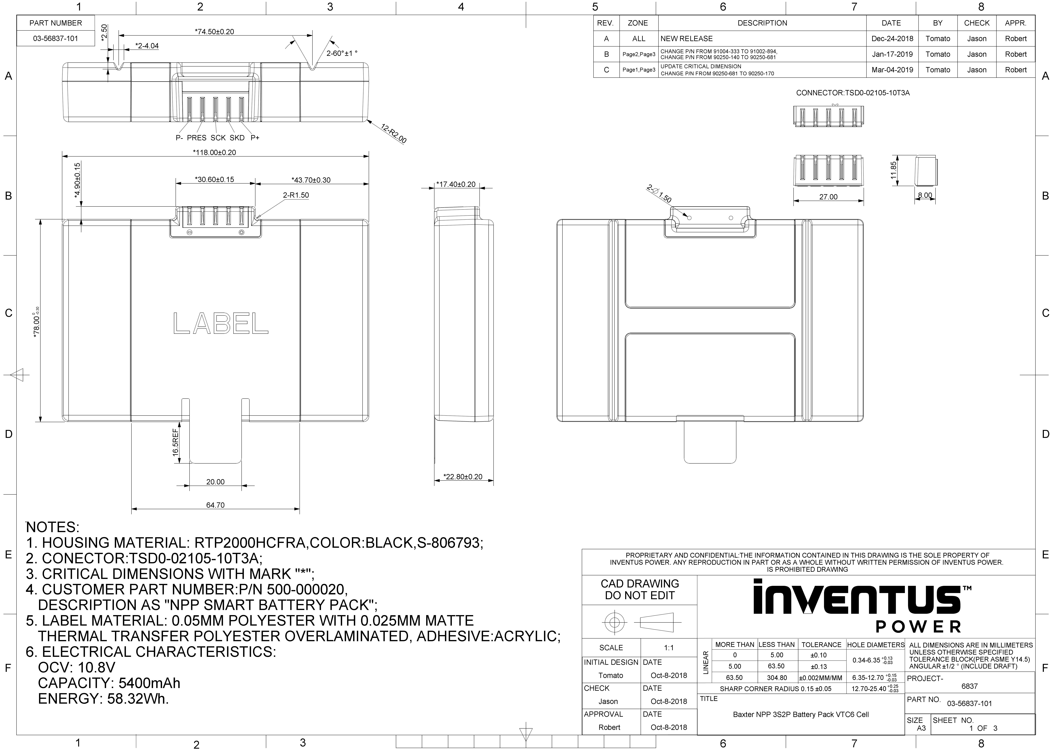
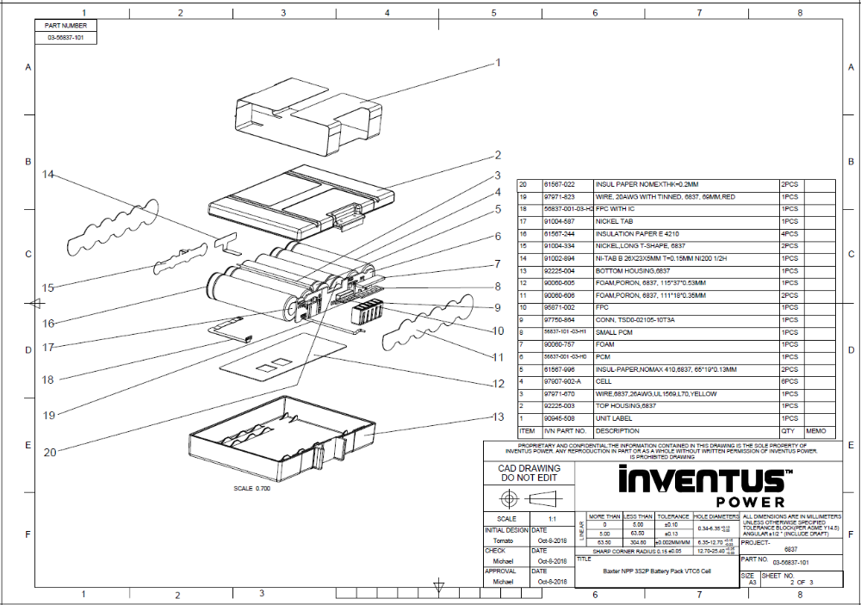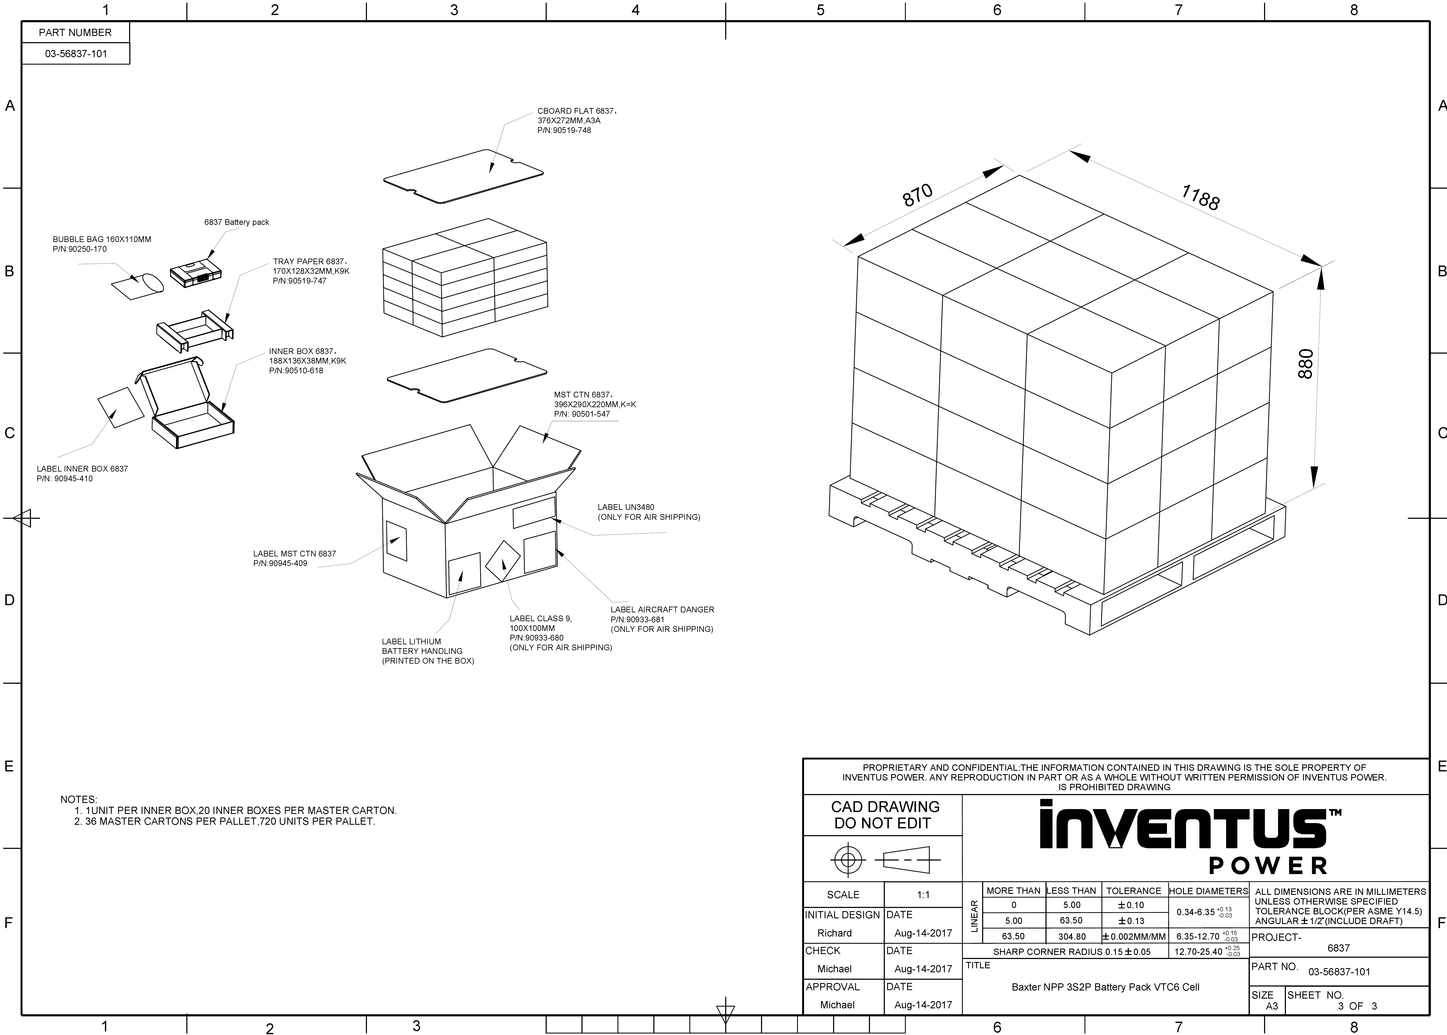

4. ELECTRICAL SPECIFICATION
  - PCBA Calibration spec.
Calibration Item | Calibration spec. | Calibrate Precision | Test setup procedure
FG Temperature | 25’C | ±3’C | Item 5.4.5
FG Voltage | 10.8V | ±20mV | Item 5.4.6
FG Offset Current | 10mA | 10mA | Item 5.4.7
FG Load Current | 2000mA | ±20mA | Item 5.4.8
  - Battery Function spec.
    - FG voltage Calibrate Precision : ±10mV
    - FG Current Calibrate Precision : ±20mA
    - FG Temperature Calibrate Precision : ±3’C
    - FG Offset Current Calibrate Precision : 10mA
    - a. THE OVER-CHARGE PROTECTION VOLTAGE : 4.20V± 25mV/cell
    - b. THE Second OVER-CHARGE PROTECTION VOLTAGE : 4.25V ± 25mV/cell
    - THE OVER-CHARGE RESET VOLTAGE : 4.0V ± 25mV/cell
    - OVER-DISCHARGE PROTECTION VOLTAGE : 2.5V±80mV/cell
    - THE OVER-CHARGE RESET VOLTAGE : 3.0V+/-80mV/cell
    - OVER-CHARGE PROTECTION CURREN : 2.5A +/-0.125A
    - OVER-DISCHARGE PROTECTION CURREN : 3.0A +/-0.15A
    - AC impedance : 90mohm max
    - Consumption CURRENT
AT shut down : 10 uA MAX
At Sleep mode : 400 uA Max
    - Charge over temperature protection : 60+/-3'C
    - Charge over temperature recovery : 55+/-3’C
    - Dis-charge over temperature protection : 65+/-3'C
    - Dis-charge over temperature recovery : 60+/-3’C
    - Electrostatic Discharge(ESD)
Contact +/-8kV
Air Discharge +/-15kV

- TEST PROCEDURE
  - Required test condition and equipment
1) All tests must be conducted in the 25℃ AMT environment.
2) Equipment Reference List
Equipment | Requirement | Quality
DC | 15V, 10A | 2
E-load | 150W | 2
Multi-Meter | --- | 1~2
Variable-Resistance Box | 0~100K | 1~2
PC | --- | 1

  - Unit’s pin diagram
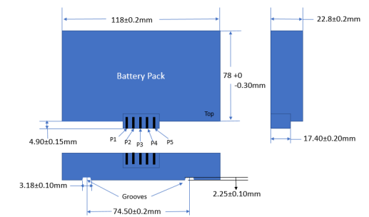
Connector  Pin Out | P+ : pin 1  SDA: pin 2  SCK pin 3  PRES: pin 4  P-: pin 5 | Cenlink Connector  P/N: TSD0-02105-10T3A

  - Test Diagram
5.3.1 PCBA TEST DIARGRAM
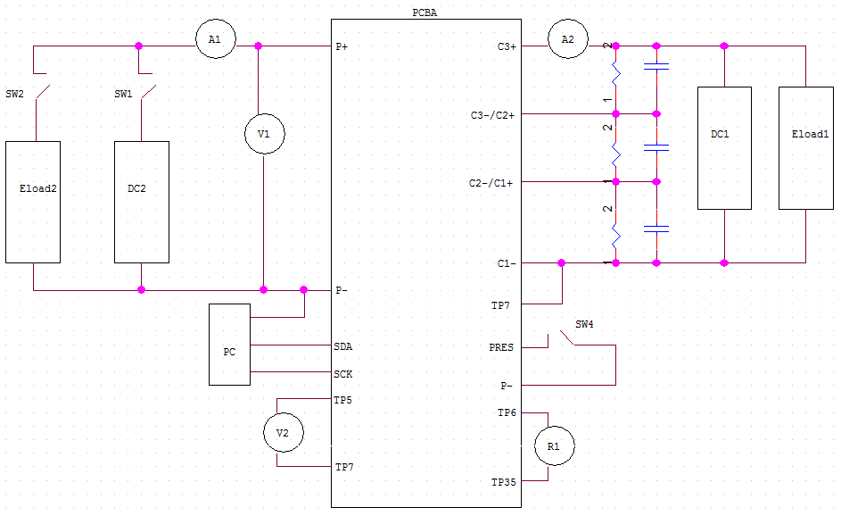
Test diagram 1
5.3.2 Final unit TEST DIARGRAM

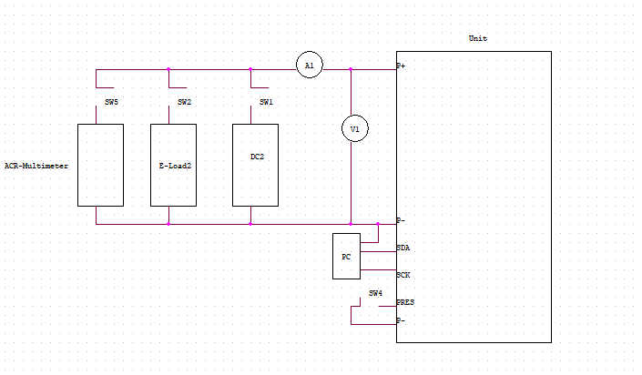

Test diagram2
5.4 PCBA Test item and procedure
Item | Test description |  |  |  | Condition | SPEC | Remark
PCBA testing
Note: before test, need to do and make sure as below:
- Short TP7 and C1-
- Test resistance between TP6 and TP35 from R1
- R1 should be less than 1R
Send “0X41” Before PCBA Test
5.4.1 |  | PCBA software program  And calibration |  | Refer to the Product information Version List in page 3
5.4.3 |  | Action before PCBA function test |  | - Short TP7 and C1-  - Test resistance between TP6 and TP35 from R1  - R1 should be less than 1R  (之后的所有测试，必须保证TP7和C1-短路，防止烧FUSE)
5.4.4 |  | Pack present input Function test |  | - Make sure TP7 short to C1-  - Set DC1=10.8V/ CC=1A  - Set DC2=12.6V,CC=100mA;  - Set E-load1 in CV model=11V/5A  - Open SW4, Close SW1.  - If A1=100mA, pack present input function is fail,  if A1=0, pack present input function is pass |  | Pass or fail | (Not test in Proto A)  Test diagram1
5.4.5 |  | Temperature Calibration Verification |  | - Make sure TP7 short to C1-, close SW4  - Read temperature(T1) from SMbus (command 0X08)  - read ambient temperature(T2) from thermometer  - calculate T1-T2 |  | ±3C | Test diagram1
5.4.6 |  | Voltage Calibration Verification |  | - Read Voltage (V2)from Smbus(command 0X09)  read voltage from V1  - calculate V1-V2 |  | ±15mV | Test diagram1
5.4.7 |  | Offset Current  Calibration Verification |  | - Read no load current(AS) from Smbus(command 0X0A)  - read no load current from A1  - AS=A1=0mA |  | +/-10mA | Test diagram1
5.4.8 |  | Load 2A Current  Calibration  Verification |  | - Make sure TP7 short to C1-, close SW4  - Set DC1=10.8V/ CC=3A  - Set DC2=12.6V,CC=100mA;  - Set E-load1 in CV model=11V/5A  - Set E-load2 in CC model=2A  - Close SW1,A1=100mA,open SW1,Close SW2  - Read load current(AS) from Smbus(command 0X0A)  read load current from A1  g. calculate AS-A1 |  | ±15mA | Test diagram1
5.4.9 |  | The First Over-Charge Protection and release |  | - Make sure TP7 short to C1-, close SW4  - Set DC1=14V/ CC=1A  - Set DC2=14V,CC=100mA;  - Set E-load1 in CV model=12V/5A  - Close SW1,A1=100mA  - Gradually increase E-load1 votage(4S each step),record charge current when A1=0, the voltage is over-charge voltage |  | a. Over-charge voltage1:  12.6V±75mv(4.20v/cell) | Test diagram1  (Allow 12.6V±100mv(4.20v/cell) for Proto A)  (Only test max. limit and min. limit to judge PASS/FAILin PP and MP)
5.4.10 |  | The Second Over-Charge Protection |  | - Make sure TP7 are short to C1-, close SW4  - Set DC1=14V/ CC=1A  - Set DC2=14V,CC=100mA;  - Set E-load1 in CV model=12V/5A  - Close SW1,A1=100mA  - Set Gradually increase E-load1 voltage(6S each step),record E-load1 voltage when the voltage between TP5 and TP7 from low(less than 0.1v) to high(more than 5v) |  | Over-charge voltage2:  12.75±75mv(4.25v/cell) | Test diagram1  (Only test max. limit and min. limit to judge PASS/FAILin PP and MP)
5.4.11 |  | Charging over temperature |  | - Make sure TP7 short to C1-, close SW4  - Set DC1=14V/ CC=1A  - Set DC2=14V,CC=100mA;  - Set E-load1 in CV model=11V/5A  - Close SW1,A1=100mA,open SW1  - Set R1=3.78K  - Close SW3 discharge current A1=0 |  | Protect  >60℃±3℃ | Test diagram1  (Not test in Proto A)  (no test after PP and MP)
5.4.12 |  | Over charge current protection |  | - Make sure TP7 are short to C1-, close SW4  - Set DC1=14V/ CC=1A  - Set DC2=14V,CC=2A;  - Set E-load1 in CV model=9.2V/5A  - Close SW1,A1=2A  - Gradually increase DC2 supply current(8S/time) until A1=0,record the current as over charge current |  | 2.5A±5% | Test diagram1  (Not test in Proto A)  (no test after PP and MP)
5.4.13 |  | Over-Discharge voltage |  | - Make sure TP7 are short to C1-, close SW4  - Set DC1=14V/ CC=1A  - Set DC2=14V,CC=100mA;  - Set E-load1 in CV model=11V/5A  - Set E-load2 in CC model=200mA  - Close SW1,A1=100mA,open SW1,Close SW2,A1=200mA  - Gradully decrease DC1 voltage(step voltage 4s/time), record DC1 voltage (V1) when A1 current=0  - The voltage(V1) is over Dis-charge protection voltage |  | Over-Discharge voltage:  7.5V±240mv(2.5v/cell) | Test diagram1  (Only test max. limit and min. limit to judge PASS/FAILin PP and MP)
5.4.14 |  | Over discharge current protection |  | - Make sure TP7 are short to C1-, close SW4  - Set DC1=10.8V/ CC=5A  - Set DC2=12.6V,CC=100mA;  - Set E-load1 in CV model=11V/5A  - Set E-load2 in CC model=2A  - Close SW1,A1=100mA,open SW1,Close SW2,A1=2A  - Gradually increase E-load current, record current (A1),when E-load1 current=0（用脉冲方式测试，脉宽时间设为D=50%=8S.  - This Current is the over discharge protect current |  | 3.0A±5% | Test diagram1  (Not test in Proto A)  (no test after PP and MP)
5.4.15 |  | Discharging over temperature |  | - Make sure TP7 are short to C1-, close SW4  - Set DC1=10.8V/ CC=1A  - Set DC2=12.6V,CC=100mA;  - Set E-load1 in CV model=11V/5A  - Set E-load2 in CC model=200mA  - Close SW1,A1=100mA,open SW1,Close SW2,A1=200mA  - Set R1=2.8K  - Close SW3 discharge current A1=0 |  | Protect  >65℃±3℃ | Test diagram1(Not test in Proto A)  (no test after PP and MP)
5.4.16 |  | Leak current |  | - Make sure TP7 are short to C1-, open SW4  - Set DC1=10.8V/ CC=1A  - Set DC2=12.6V,CC=100mA;  - Set E-load1 in CV model=11V/5A  - Close SW1,A1=100mA,open SW1  - record A2 current as the sleep model leak current  - Send command to shut down the battery pack  Confirm SMBUS communication have been shut down  - record A2 current as the shut down mode leak current |  | 400uA in sleep model  10uA in shut down model | Test diagram1  (No need to test sleep mode after PP and MP)
Final units testing
成品测试
Need close SW4 during all the unit Test
5.5.1 |  |  | CAPACITY DISTRIBUTION | - Control Cell SOC to 20% to 30%.  - Use same lot and same data code (same capacity rank) cell in same battery pack.  - Different cell voltage in same battery pack less than 3.5mV (Vcell_max - Vcell_mix<3.5mV).  - Different cell impedance in same battery pack less than 1m ohm (Rcell_max - Rcell_min<1m ohm).
5.5.2 |  |  | Software part
5.5.3.a |  |  | Cell voltage deviation | - Read the Voltage of cell1,cell2 and cell3 from Smbus  - calculate Vcell(max)-Vcell(min)  (Cell voltage command:  BQ8050:  0x3D CellVoltage3()  0x3E CellVoltage2()  0x3F CellVoltage1()； |  | Vcell(max)-Vcell(min)<10mV | Unit Test diagram2
5.5.3.c |  |  | FG Temp. Calibrate Precision verify | - Close SW4  - Read temperature(T1) from Smbus(command 0X08)  - read ambient temperature(T2) from thermometer calculate /T1-T2/ |  | 0’C</T1-T2/<3’C | Unit Test diagram2
5.5.3.d |  |  | FG voltage Calibrate Precision verify | - Read Cell stack voltage(Va) with no load from SMBus (command 0X09)  - Read no load voltage(Vb) between “P+(pin1)” and “P-(pin5)” from multimeter,  - calculate/ Va-Vb / |  | 0mV</Va-Vb/<20mV | Unit Test diagram2
5.5.3.e |  |  | FG Offset Current Calibrate Precision verify | - No load between“P+(pin1)” and “P-(pin5)”  - Read current(Ia) from Smbus(command 0X0A) |  | +/-10mA | Unit Test diagram2
5.5.3.f |  |  | FG Current Calibrate Precision verify | - Set E-load2 to CC2A  - Close SW2, Read input current(A2) from multimater  - Read current(A1) from Smbus (command 0X0A)  - Calculate/ A2-A1/ |  | 0mA</A2-A1/<20mA | Unit Test diagram2
5.5.4 |  |  | Over-charging current | - Close SW4  - Set DC1 in 14V/12A;  - Close SW1, A1=2A  - Gradually increase DC1 supply current(8S/time) until A1=0,record the current as over charge current  - Decrease DC1 current to 100mA, and A1 current occurs. |  | 2.5A±5%  PASS/FAIL | Test diagram2  (Only test max. limit and min. limit to judge PASS/FAILin PP and MP)
5.5.4.a |  |  | Charging with max. charging current(2A)  依据客人规格最大充电电流设定 | - Set DC2 to 2.0A, close SW1 for about 4S, charge current should be 2.0A, no protection occurs |  | Charging with max. charging current(2A): Pass/Fail | Test diagram2
5.5.4.b |  |  | CHG FET confirm | - Sent Command “0X00”, data”0X40” to close CHG FET, charging should disable, and current should be 0  注：电流过大需要先将电流降下来再关管，以免损坏Mosfet |  | Pass/Fail | Test diagram2
5.5.5 |  |  | Over-discharging current | - Close SW4  - Set DC1 in 12.6v/100mA;  - Set E-load1 in CC model=2A  - Close SW1, A1=100mA  - Open sw1，Close SW2,A1=2A  - Gradually increase E-load current, record current (A1),when E-load1 current=0（用脉冲方式测试，脉宽时间设为D=50%=8S.  - Open SW2,close SW1,A1=100mA,  - Set Eload1 to 100mA,open SW1,close SW2,A1=100mA |  | 3A±5%  PASS/FAIL | Test diagram2  (Only test max. limit and min. limit to judge PASS/FAILin PP and MP)
5.5.5.a |  |  | Discharging with max load(2.35A)  依据客人规格最大放电电流设定 | - Sent Command “0X00”, data”0X40” to open CHG FET,  - Set E-load2 to2.35A, close SW2 for about 3S discharge current should be 2.35A, no protection occur  - After 3S, measure CCV. |  | Discharging with max load(2.35A):  Closed circuit voltage:  8.25V-10.92V | Test diagram2
5.5.5.b |  |  | DSG FET confirm | - Sent Command “0X00”, data”0X40” to close DSG FET, discharging should disable, and current should be 0  注：电流过大需要先将电流降下来再关管，以免损坏Mosfet |  | Pass/Fail | Test diagram2
5.5.6 |  |  | Short circuit test | - Close SW4  - Short battery P+ and P- connector resistor<100 mohm,output current =0A  - Remove short state, output voltage release normal |  |  | Test diagram2  Not test in PP and MP
5.5.7 |  |  | ACR Test | - Close SW4  - Set impedance meter in AC model, frequence=1K HZ  - Test internal impedance at P+ and P-  - Set E-load2 to A mode: CC 1.0A/3S; B mode: CC 2.0A/3S;  - Close SW2, Turn E-load2 from A mode to B mode,  - After A mode discharge for 2.9S, record voltage(Va)from V1;  - After B mode discharge for 2.9S, record voltage(Vb)from V1;  - Calculate △CCV =Va-Vb  - (Note: the detecting point of voltmeter V1 should be closed to the connector, so that it can decrease the impedance of outside circuit to effect the test result )  - Close SW4  - Close SW5  - Get the value from ACR-Multimeter. |  | 65mohm max,  40mohm min. | Test diagram2
5.5.7.b |  |  | Pack present input Function verify | - Open SW4  - If V1<500mV, pack present input function is pass, if V1>500mV, pack present input function is fail |  | Pass or fail
5.5.8a |  |  | Write Manufacture Information | (1) Write Manufacture Data  - Tool: EV2300, Battery Management Studio(bqstudio)  - Accross below formula write the HXE value into battery pack through command 0x1B.  - Formula :  (Year - 1980) * 512 + Month * 32 + day  - Such as current day is 5/23/2017, so the YYYY is 2017 and the MM is 05. the data is 23 . So calculate the value is ( 2017-1980)*512 + 05*32 + 23 = 19127 0x4AB7, then at command 0x1B write value 0x4AB7 into battery pack.  (2) Write Serial Number  - The Serial format is 0x0001~FFFF  - At command 0x1C write the HEX into battery pack for every battery.  - Such through command 0x1C write value 0x0001 into the first battery pack, then write 0x0002 value into the second battery back. |  |  | Test diagram2
5.5.8b |  |  | Verify Manufacture Information | - Verify Manufacture Data  - Tool: EV2300, Battery Management Studio(bqstudio  - Read command 0x1B, Compare if the read back value is the same as the write value Pass Otherwise Fail  - Verify Serial Number  - Tool: EV2300, Battery Management Studio(bqstudio)  - Read command 0x1C, Compare if the read back value is the same as the write value Pass Otherwise Fail |  |  | Test diagram2
5.5.9 |  |  | Fuel Gauge Learning | - Discharge the battery with 12W（TBD）constant discharge power to discharge until the Cell voltage < 3000mV then stop discharging;  - Relax without charging or discharging for at least 6.5 hours after stop discharging;  - Charge the battery with 12300mV@ 2000mA（TBD）continuously until SOC = 100 then stop charging;  - Relax Without charging or Discharging for at least 6.5 hours after reaching full charge;  - Discharge the battery with 12W（TBD）constant discharge power to discharge until the Cell voltage < 3150mV (TBD) then stop discharging.  All above learning step must be meet below conditions.  a. The temperature of all step must be between 15°C - 60°C (with closest to 25°C as the ideal goal).  b. During charging the charging status cannot be interrupted or stop.
5.5.12 |  |  | △OCV after five days | - Rest battery pack 2hour, and then test OCV1 with link SN code.  - Rest battery 5 days, and then test OCV2 with link SN code.  - Calculate △OCV=OCV1-OCV2. |  | 100mV max | Unit Test diagram2
5.5.10 |  |  | Shipment OCV and SOC, FCC | - Read the SOC (command 0X0D) and FCC (command 0X10) from SMbus,  - test the no load output voltage with multimeter when ship out |  | a. record FCC and SOC  b. OCV:  9.6V~10.92V
5.5.11a |  |  | Shut down operation | Send 0x00,0x0010 command to Battery Pack |  | PASS/FAIL | Test diagram2
5.5.11b |  |  | Verify shut down when shipping | Read SMBus 0x09 command data is failure  Check pack voltage < 200mV |  | PASS/FAIL | Test diagram2

6.Mechanical requirements/test:
6.1 Unprotected drop
The battery pack must be dropped at a height of 1meter on all sides so it strikes a wooden surface. Each sample is to be dropped three times on each side (18 drops total). Acceptance Criteria: There shall be no leakage, no venting, no rupture, no explosion, no fire during this test and battery pack shall function electrically, per specifications.

6.2 INGRESS PROTECTION RATING
The entire battery pack is to be IPX4 rated, which includes the battery pack enclosure and
female connector.

6.3 Vibration test.
a) Check initial function and appearance of each sample before testing.
b) Test condition as below:
Using vibration profiles of Figure 514.6C-1 and the value of Table 514.6C-11, test
duration shall be one hour in each axis.
c) After test, re-check the functional and appearance of each sample.
All samples should be remained fully function and no scratched or cracked symptom
after all test.

7. QUALITY ASSURANCE REQUIREMENT

7.1 QA Product Verification
Detail inspections, functional test, environmental test and reliability test will be carried out at both design and manufacturing stages. The procedure is in line with product quality plan.

  - Incoming Quality Control (IQC)
Sample will be drawn from every lot delivered according to the ANSI/ASQC Z1.4 procedure followed is per the F.I.L. incoming material review board flow chart. The inspection criteria will be in line with the F.I.L. engineering sample approval report (SER) and drawing.

  - Testing
Testing will be carried out at initial and final test station to guarantee that every unit leaving the factory will meet the requirement in section 5.

  - QC Audit
All units, which are pass QC final test and packaging will be randomly sampled by QC audit team. Lot size will depend on standard ANSI/ASQC Z1.4.

PRE-SHIPMENT AUDIT - LEVEL S3
OUTGOING - LEVEL II
1). SAMPLING TO CHECK CAPACiTANCE OF BATTERY PACK --- 5400mAH MIN FOR EACHE LOT; THE TEST CONDITION AS FOLLOW:

STANDARD CHARGING: CC 2000mA UNTIL THE PACK ATUO PROTECTION
STANDARD DISCHARGING: CC 1080mA UNTIL THE PACK ATUO PROTECTION

2).SAMPING TO CHECK THE SELF-DISCHARGE VOLTAGE DROP FOR EACH LOT, THE AVERAGE VALUE SHOULD BE 2mV/ PER DAY.

  - Engineering Change

Design change should be carried out in according with engineering change notice

- Package And Label
8.1 Unit label (refer to the latest label drawing 90945-508 )

8.2 Packaging drawing(refer to latest drawing 03-56837-101)

Appendix 1:
PCB drawing
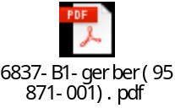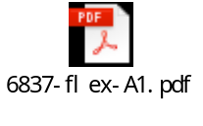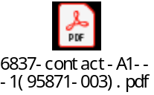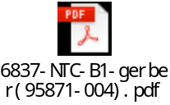
Appendix 2:
Schematic
Refer to EQMS
Appendix 3:
Assembling drawing
Refer to EQMS
Appendix 4:
Assembling flowchart
N/A

Appendix 5:
PCM label

Appendix 6:
Unit label
Refer to EQMS

Appendix 7:
Outer box label
Refer to EQMS

Appendix 8:
Inner box label
Refer to EQMS

Appendix 9:
PCBA label
Refer to EQMS

